**Project Report Template**

1. **INTTODUCTION**

**1.1 Overview**

**In this project, we use custom objects, relationships, page layouts to give the HR team easy access to data they need on an existing recruitment app.**

**1.2 Purpose**

**To make the existing app more efficient for the HR team we create custom objects and relationships to store and access the data more efficiently. We install an unmanaged package in the org to get metadata that acts as existing data in the recruitment a**

**2 Problem Definition & Design Thinking**

**2.1 Empathy Map**

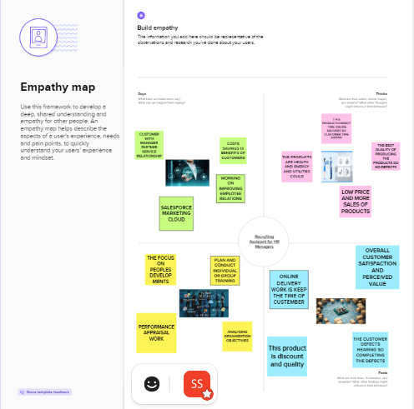

**2.2 Ideation & Brainstorming Map**

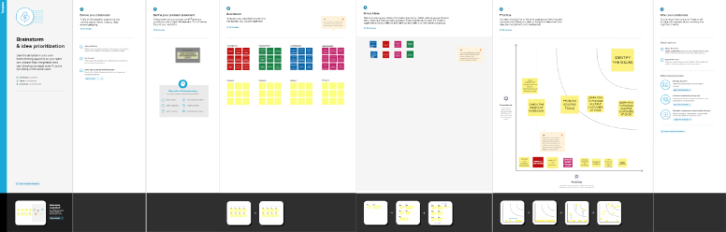

**3. RESULT**

**3.1 Data Model**

|  |  |  |
| --- | --- | --- |
| **Object Name** | **Field Lable** | **Data type** |
| **Job Posting Site** | **Job Posting Sites** | **Text** |
| **Review** | **Reviews** | **Auto Number** |

**3.2 Activity & Screensht**

**TO Create a custom object for Job Posting Sites To create a custom object, follow these steps :**

**1. From setup click on object manager**

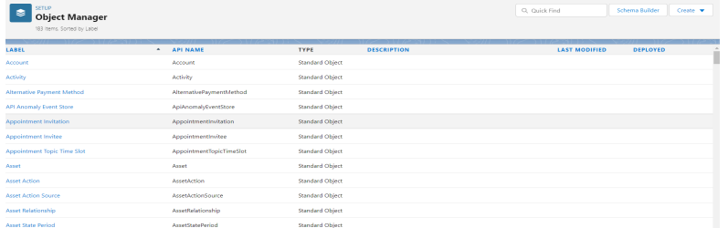

**2. Click create, select custom object**

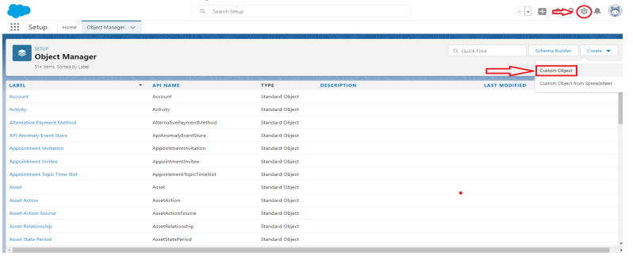

**3. Fill in the label as "Job Posting Site".**

**4. Fill in the plural label as "Job Posting Sites"**

**. 5. Record name : "Site Name"**

**6. Select the data type as "Text"**

**. 7. In the Optional Features section, select Allow Reports and Track Field History.**

**8. In the Deployment Status section, ensure Deployed is selected.**

**9. In the Search Status section, select Allow Search.**

**10. In the Object Creation Options section, select select these options: Add Notes and Attachments related list to default page layout Launch New Custom Tab Wizard after saving this custom object**

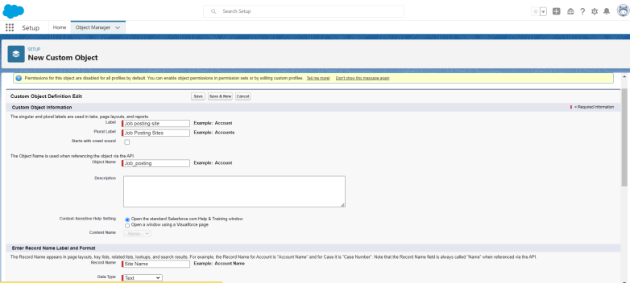

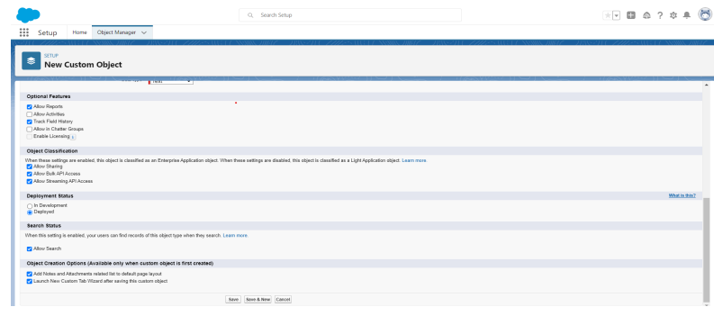

**1.1 Leave everything else as is, and click Save**

**Activity-2**

**Create a custom object for reviews To create a custom object, follow these steps :**

**1. From setup click on object manager.**

**2. Click create, select custom object.**

**3. Fill in the label as "Review".**

**4. Fill in the plural label as "Reviews".**

**5. Record name : "Review Number"**

**6. Select the data type as "Auto Number".**

**7. Under display format enter "REV-{0000}".**

**8. Enter the starting number as 1.**

**9. In the Optional Features section, select Allow Reports and Track Field History.**

**10. In the Deployment Status section, ensure Deployed is selected.**

**11. In the Search Status section, select Allow Search.**

**12. In the Object Creation Options section, select Add Notes and Attachments related list to default page layout.**

**13. Leave everything else as is, and click Save.**

**Activity :**

**How to create a tab As we selected to launch a custom tab wizard in step 10, a custom tab wizard appears wherein we customize the look of the Job posting site object's tab. To do that :**

**1.To Select Tab Style:**

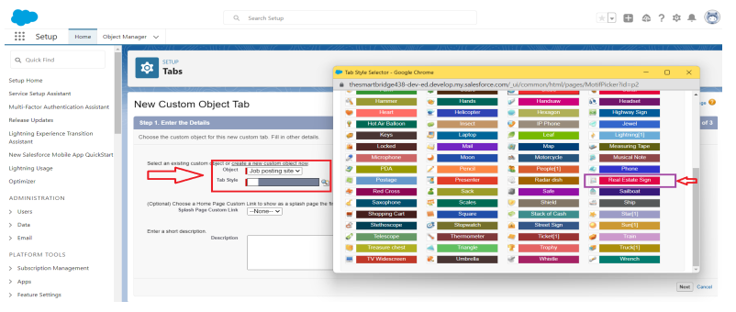

**2. Click Next.**

**3. Leave the profile as is and click Next.**

**4. In the Add to Custom Apps section:**

**5. Deselect Include Tab.**

**6. Select Append tab to users’ existing personal customxizations.**

**7. Click Save.**

**Fields**

**Create New Field for Job Posting site**

**From the object manager, click on the job posting site, then click on Fields & Relationships.**

**1. Click on new**

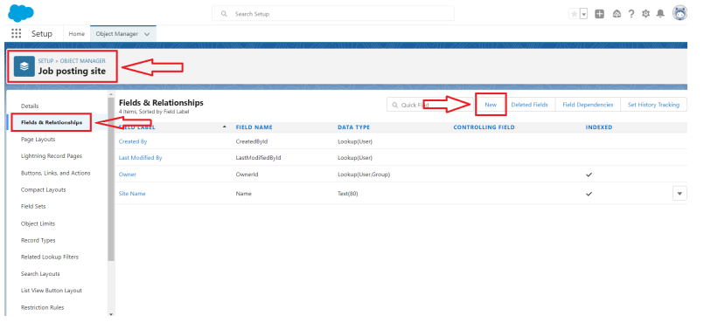

**2.Select the data type as URL.**

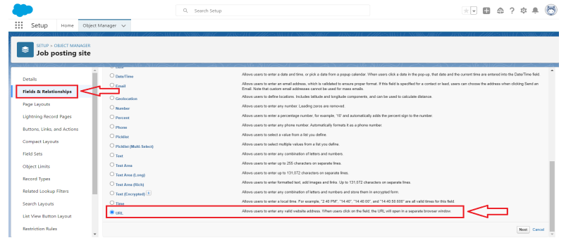

**3.Click Next**

**4.For Fields Label,enter the Job Posting Site Site URL.**

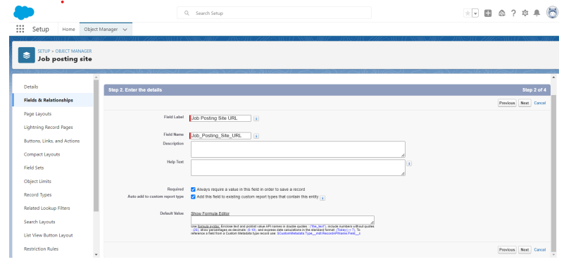

**5.Click Next,Next, and click Save & New**

**4 Trailhead Profile Public**

**Team Lead –**[**https://trailblazer.me/id/sands75**](https://trailblazer.me/id/sands75)

**Team member1-**[**https://trailblazer.me/id/atamilselvi1**](https://trailblazer.me/id/atamilselvi1)

**Team member2-**[**https://trailblazer.me/id/banup19**](https://trailblazer.me/id/banup19)

**Team member3-**[**https://trailblazer.me/id/bakash12**](https://trailblazer.me/id/bakash12)

**5. ADVANTAGES**

* **Good public relations**
* **Opprtunity to develop mid- and top-level managers**
* **Morale building**
* **Encouragement of employees and members of protected groups**
* **Knowledge of existing employee performane**
* **Cost-savings**

**Candidates knowledgeof the organization**

**DISADVANTAGES**

* **Possible inferiority of internal candidates**
* **Infighting and morale problems**
* **Potential inbreeding**

**6. APPLICATIONS**

* **Basic employee records**
* **Statistical analsis of flucation, planning the need for labour force**
* **Management of business description and specification data, analysis of orgaizational structure**
* **Process planning, documentation recruitment implementation**
* **Performance measurement**
* **Creation of salary structure, salary modeling, level of compensation analysis**

**CONCLUSION**

* **In conclusion,the practice of HR needs to be integrated with the overall strategy to ensure effective use of people and provide better returns to the organizations in terms of ROI for every dollar or rupee spent on them.**
* **Human resource development is a mean to an end is usually acknowledged to be getting better result from the organization, teams and individuals by understanding and managing performance within an agreed framework of planed golals objectives and standards**

**8 FUTURE SCOPE**

* **HR ASSISTANT \ INTERN**
* **HR SPECIALIST**
* **HR GENERALIST**
* **RECURUITER**
* **HR MANAGER**
* **HR DIRECTOR**
* **VP OF HR \CHRO**